END OF SCHOOL YEAR ACTIVITIES
Try
FOOTGOLF
@ Mount Pleasant Golf Club

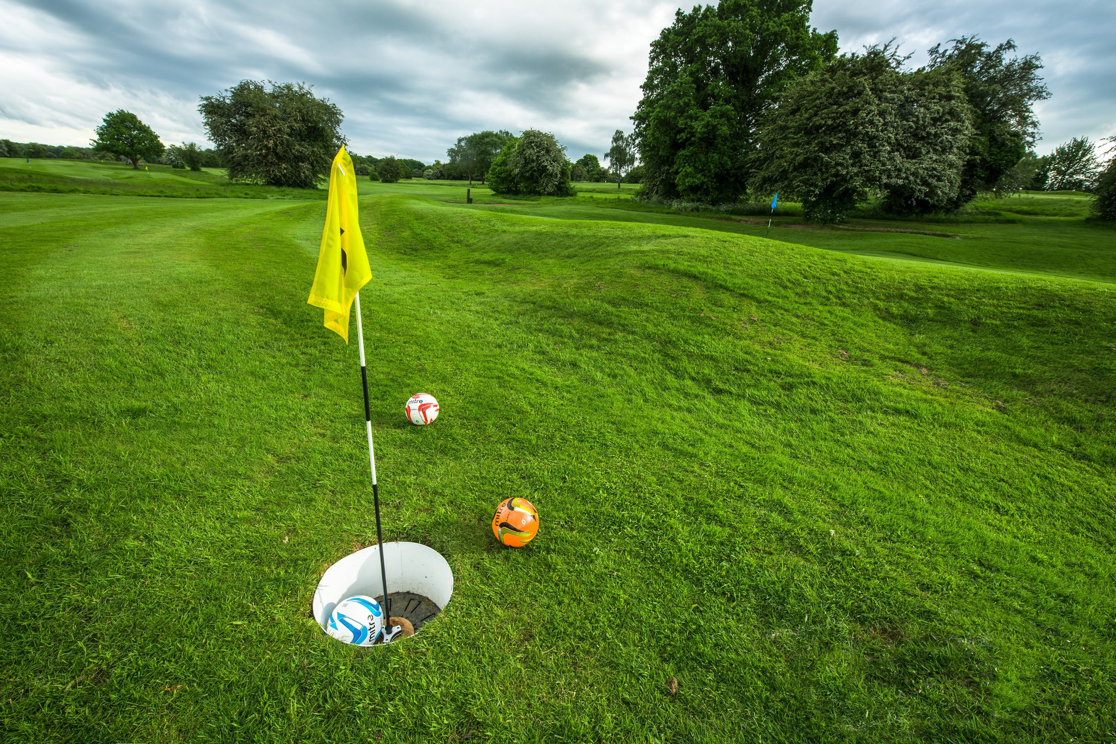  Footgolf | 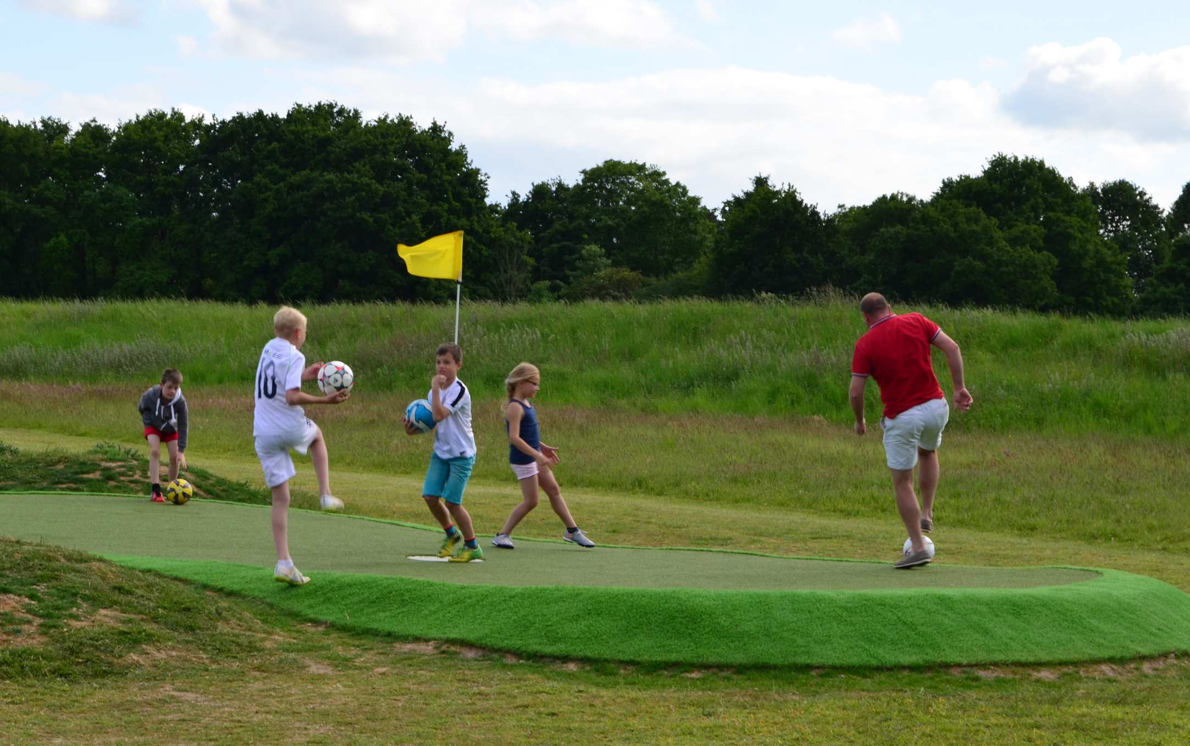
+ Hotdog
(or vegetarian option)

+ soft drink

$10.00 per player

(accompanying teachers are complimentary.)
Contact Dave Swann on 0438095231 or dave.footgolfsa@outlook.com for bookings

Our 18 - hole, Par 72 course is the only championship FootGolf course in South Australia.
It offers a challenge for those serious about their football skills whilst for all it offers a kick and giggle opportunity as friendly and inclusive introduction to the elements of golf.
The course is set up as two 9 - Hole courses which can combine for an 18 Hole course. In groups of 4 -5 it is possible to play 9 holes in approx. 70 minutes and 18 holes in 2.5 hours.
This offer is for groups of 12 to 80 players

Please checkout our web page at
<footgolfsa.weebly.com>

